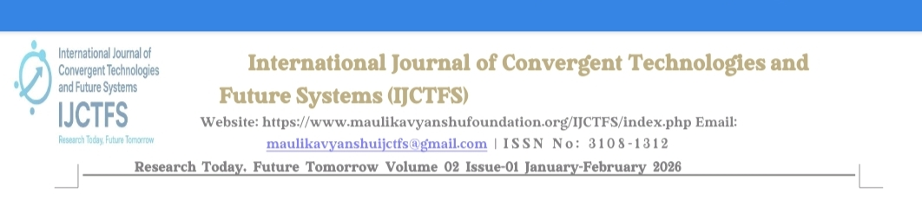
IMPACT OF ARTIFICIAL INTELLIGENCE ON JOB MARKET
Author name: Roshani Anil Jain
Abstract
This research paper searches the revolutionary role of artificial intelligence (Al) within the international labour market, specifically examining how rapid technological progress is restructuring the modern workforce. The study examines the “dual-edged” nature of Al integration: its potential to cause widespread job replacement alongside its capacity to generate entirely new professional categories. By synthesizing existing literature & empirical data, this paper clarifies a shifting employment paradigm where Al serves as both an automation tool for repetitive tasks & a catalyst for industrial foundation. While traditional roles may face ancientness, the technology simultaneously facilitates the architecture of new career paths across sectors ranging from technical support to the creative arts.
However, the shift brings significant economic friction for replaced workers, requiring a complex balance of organizational efficiency & social responsibility. Finally, the research maps these industrial trends & evaluates public sentiment regarding the future of work.
INTRODUCTION
The intersection of Al & global employment represents a multidimensional collaboration between human labor & technological evolution. As Al capabilities accelerate, they challenge established employment models & redraw the functional boundaries of the market. This shift is characterized by a transition from early symbolic logic to modern machine learning (ML) & deep learning architectures capable of high-level reasonable tasks.
Contrary to historical assumptions that automation would only threaten low-skilled manual labor, current trends show that high-skilled, reasonable roles are equally susceptible to Al-driven simplification. While these technologies optimize organizational efficiency, they necessitate a radical change in workforce composition & skill requirements. To mitigate risks such as wage inequality & labor displacement, proactive strategic planning is required from both corporate leaders & policymakers.
RESEARCH OBJECTIVES
- To studies the expanse of job displacement caused by AI Implementation in various Industries.
- To estimate the role of AI in creating new job opportunities & skill demands in emerging Sectors.
- To identify factors influencing the adoption of AI technologies in the Labor market.
- To research the role of Artificial intelligence in job market.
- To rese strategies for mitigating potential negative impacts of AI On workforce Participation & income distribution.
- To examine both positive & negative impacts of Artificial intelligence on job market.
- To Evaluate How Artificial intelligence affects job market.
- To investigate the socio-economic implications of AI-driven change s In employment Pattern.
HYPOTHESES
H1. Do you think government should interfere to regulate the impact of Al On Employment?
 | Oi | Ei | Oi-Ei | (Oi-Ei)2 | (Oi-Ei)2/Ei
Yes | 76(59.8%) | 42.33 | 33.67 | 1132.6 | 26.78
No | 30(23.6%) | 42.33 | -12.33 | 152.0 | 3.59
Maybe | 21(16.5%) | 42.33 | -21.33 | 454.9 | 10.74
Total | 127 | - | - | - | 41.11

Σ(Oi-Ei)2/E=41.11
Degree of freedom =3-1=2
Calculated X2=41.11
Tabulated X2= 5.99
Since 41.11>5.99, Hypothesis Rejected.
H2. How often do you use Al in your work?
 | Oi | Ei | Oi-Ei | (Oi-Ei)2 | (Oi-Ei)2/Ei
Daily | 61(48.0%) | 31.75 | 29.25 | 855.5 | 26.94
Monthly | 32(25.2%) | 31.75 | 0.25 | 0.0625 | 0.001
Weekly | 26(20.5%) | 31.75 | -5.75 | 33.0 | 1.03
Never | 8(6.3%) | 31.75 | -23.75 | 564.0 | 17.76
Total | 127 | - | - | - | 45.7

Σ(Oi-Ei)2/E=45.7
Degree of freedom =4-1=3
Calculated X2=45.7
Tabulated X2= 7.81
Since 45.7>7.81, Hypothesis Rejected.
DATA ANALYSIS
1.How often do you use Al in your work?

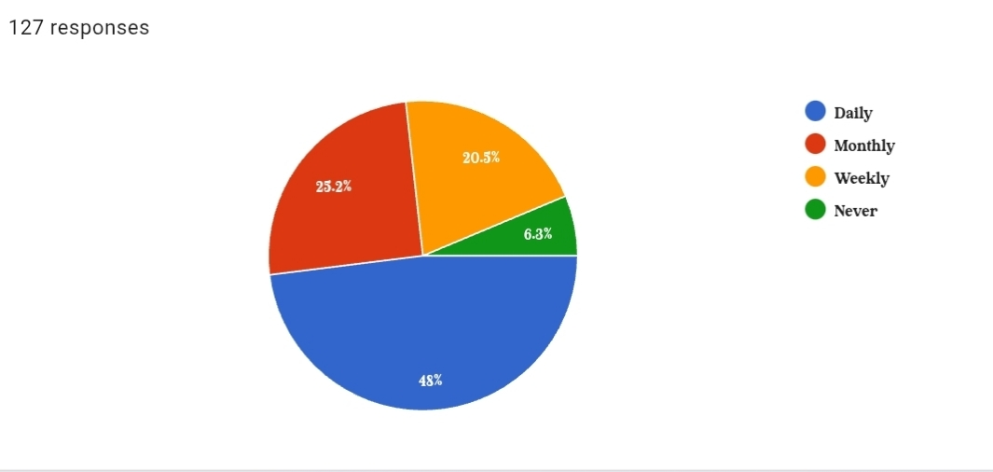
2. Al tools have the latentl to make employees more efficient & productive in their Work?
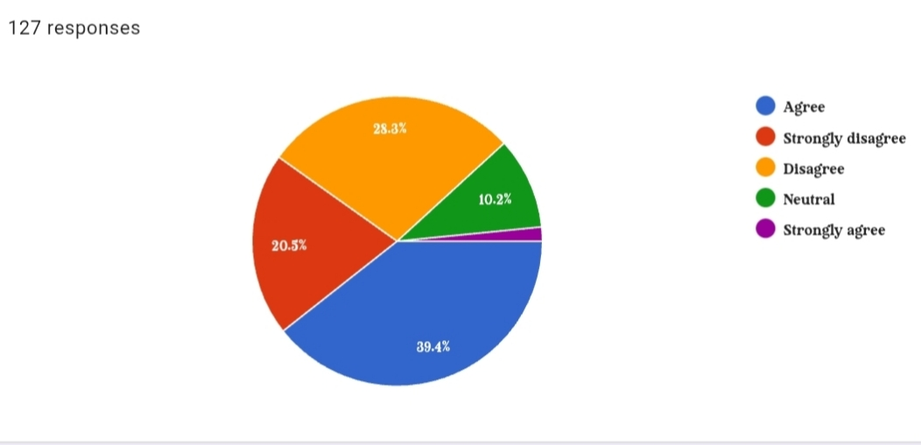
3. How prepared do you feel to adapt to changes in the job market due to Al?
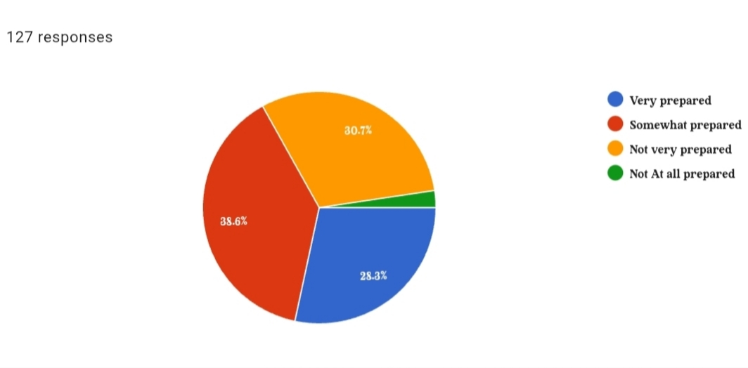
4. Do you think government should intervene to regulate the impact of Al On Employment?
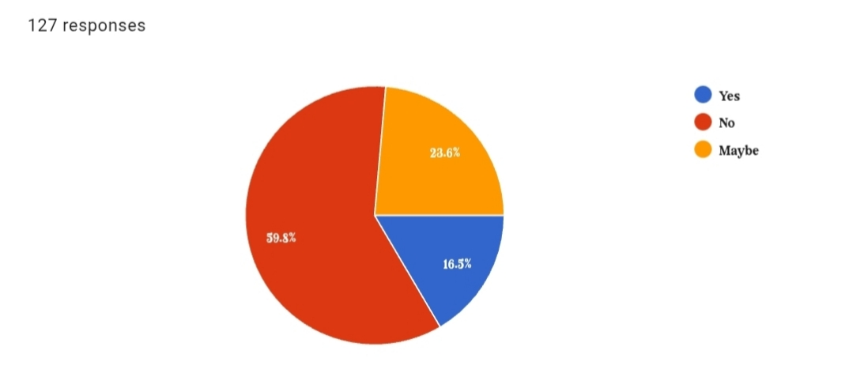
5. How are you Familiar with the term “Artificial intelligence(Al)”?

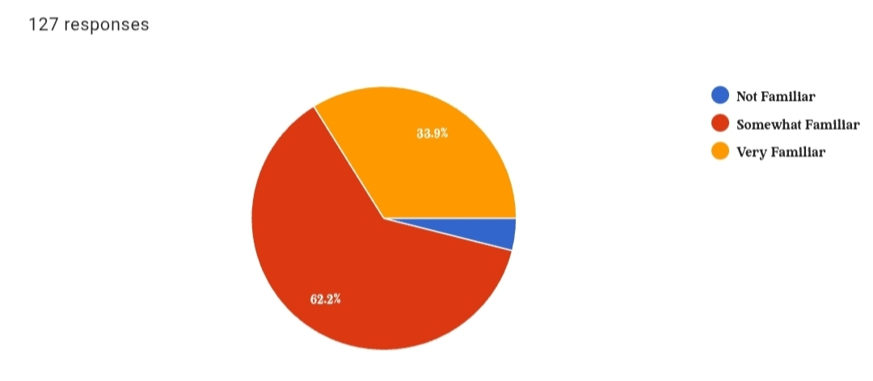
CONCLUSION
As per My research I Conclude That The impact of Al on employment is a complex, multi-layered issue involving technological, economic, & societal shifts. While Al boosts foundation & efficiency, its widespread adoption poses risks to job security & social equality. Labor market changes are now considered possible. as Al integrates into business, many routine & traditional roles will disappear.
However, this does not signal the end of human work. Historically, new technologies have always paved the way for brand-new industries. There is an expected surge in demand for specialized skills in machine learning & data science. To manage this transition, policymakers must proactively create ethical regulations, protect worker rights, & invest heavily in education & training programs.
REFERENCES
1.Acemoglu, D., & Restripe, P. (2020). The Impact of Artificial Intelligence on Labor Market Dynamics.
2.Adams, S., et al. (2022). AI, Employment, & Skills: A Systematic Review. Journal of AI & Employment Trends.
3.Brown, M. (2018). The Impact of AI on Employment: A Comparative Analysis of Developed & Developing Economies.
4.Brynjolfsson, E., & McAfee, A. (2014). The Second Machine Age: Work, Progress, & Prosperity in a Time of Brilliant Technologies.
5.Doe, J. (2020). The Future of Employment in the Age of Artificial Intelligence.
6.Frey, C. B., & Osborne, M. A. (2013). The Future of Employment: How Susceptible Are Jobs to Computerization? Technological Forecasting & Social Change.
7.Garcia, R. (2020). The Impact of AI on Employment Dynamics: Evidence from Firm-Level Data.
8.Johnson, E. (2021). Artificial Intelligence & Employment Trends: A Meta-Analysis.
9.Martinez, L. (2019). AI & Employment: Perspectives from Industry Experts.

